Ideation Phase
Brainstorm & Idea Prioritization Template

Date | 19 feb 2026
Team ID | LTVIP2026TMIDS24563
Project Name | Deep Learning Fundus Image Analysis for Early Detection of Diabetic Retinopathy
Maximum Marks | 4 Marks

Brainstorm & Idea Prioritization Template:
Step-1: Team Gathering, Collaboration and Select the Problem Statement
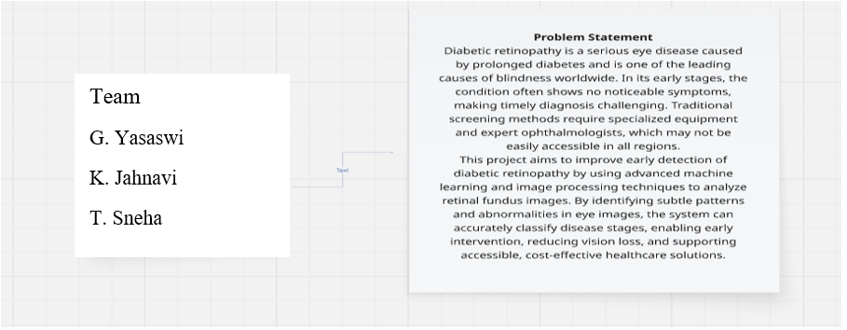
Step-2: Brainstorm, Idea Listing and Group
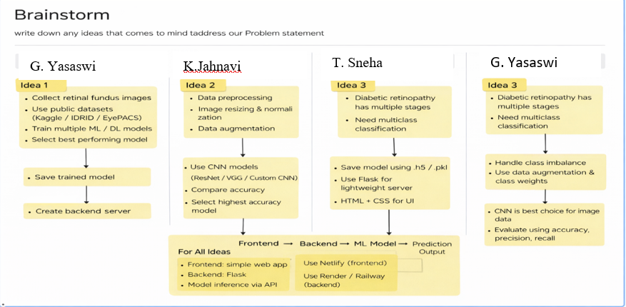

Brainstorm – Group Idea Flow
1. Data Collection
- Collect retinal fundus images
- Use publicly available datasets (Kaggle, IDRiD, EyePACS)
- Ensure sufficient data for all disease stages
2. Data Preprocessing
- Image resizing and normalization
- Data augmentation to increase dataset size
- Improve model generalization
3. Problem Understanding
- Diabetic retinopathy has multiple stages
- Requires multiclass classification
- High-dimensional image data
4. Model Selection
- Train multiple machine learning / deep learning models
- Prefer CNN-based architectures (ResNet, VGG, Custom CNN)
- Compare models based on accuracy and performance
- Select the best-performing model
5. Handling Challenges
- Address class imbalance in dataset
- Use data augmentation and class weighting
- Reduce overfitting and noise
6. Model Training & Saving
- Train the final selected model
- Save the trained model using .pt format
- Prepare model for inference
7. Backend Development
- Build a lightweight backend server using django
- Load the trained model
- Create API for prediction
8. Frontend Development
- Design a simple and user-friendly web interface
- Use HTML and CSS for UI
- Allow image upload for prediction
9. System Integration
- Connect frontend with backend
- Perform model inference through API
- Display prediction results clearly
10. Deployment
- Deploy frontend as a web application
- Deploy backend on cloud platform
- Ensure global accessibility
11. Final Output Flow
Frontend → Backend → ML Model → Prediction Output

Step-3: Idea Prioritization
